

Bachelor of Computer Applications
Semester – V
Business Analytics
Experiment No : 2
Title: Superstore Sales Performance Analysis Using Power BI

Submitted By:
Name: Keerthana R
Reg. No : 2411020240021
Date:31/8/2026

Submitted To:
Faculty Name: Mr. Aman Kumar Sharma

Department of Computer Application
Alliance University
Chandapura - Anekal Main Road, Anekal
Bengaluru – 562106

Experiment No : 2
Problem Statement
Management wants to quickly understand sales performance across products, categories, and regions. Create appropriate Power BI visualizations to identify key business patterns.

1. Introduction
The objective of this project is to develop an interactive Power BI dashboard that helps management quickly understand sales performance across products, categories, and regions. The dashboard converts raw sales data into meaningful visual insights that support business analysis and decision-making.
The dashboard focuses on key performance indicators such as Total Sales, Total Profit, Profit Margin, Total Orders, Units Sold, and Total Customers. Interactive slicers allow users to analyze the business by region, category, segment, and order date.

2. Dataset Description
The project uses the Superstore sales dataset, which contains 9,994 records and 19 attributes.
Important fields used in the dashboard include:
- Order Date
- Ship Date
- Customer
- Segment
- Country
- State
- Region
- Category
- Sub-Category
- Product Name
- Sales
- Quantity
- Discount
- Profit
The dataset provides information about customer transactions, products, geographical areas, sales, and profitability.

Data Preparation
The dataset was prepared in Power Query before creating the dashboard.
The main preparation activities included:
- Checking and correcting data types.
- Ensuring Order Date and Ship Date were stored as Date fields.
- Setting Sales and Profit as decimal number fields.
- Setting Discount as a decimal number and displaying it as a percentage.
- Checking duplicate records.
- Creating Month Name and Month No for monthly analysis.
- Ensuring geographical fields such as State, Country, and Region were correctly categorized.
These steps helped ensure that the data could be used reliably in Power BI visualizations.

4. DAX Measures
The following measures were created to calculate the key business indicators.

Total Sales
Total Sales = SUM('Superstore'[Sales])

Total Profit
Total Profit = SUM('Superstore'[Profit])

Total Orders
Total Orders = DISTINCTCOUNT('Superstore'[Order ID])

Units Sold
Units Sold = SUM('Superstore'[Quantity])

Profit Margin
Profit Margin = DIVIDE([Total Profit], [Total Sales], 0)

Total Customers
Total Customers = DISTINCTCOUNT('Superstore'[Customer ID])

Dashboard Visualizations
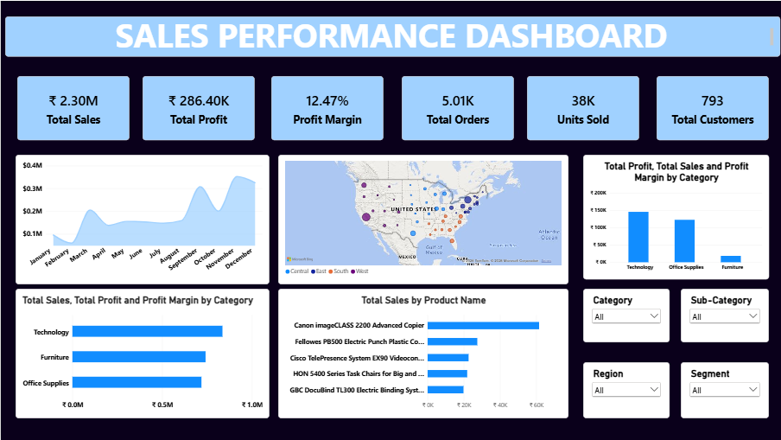

5.1 KPI Cards
The dashboard contains KPI cards for:
- Total Sales: ₹2.30M
- Total Profit: ₹286.40K
- Profit Margin: 12.47%
- Total Orders: 5.01K
- Units Sold: 38K
- Total Customers: 793
These KPIs provide management with an immediate overview of overall business performance.

5.2 Monthly Sales Trend
A line chart was used to display sales performance across months.
Fields used:
- X-axis: Month Name
- Y-axis: Total Sales
The visualization helps identify fluctuations in sales throughout the year and provides a quick understanding of seasonal sales patterns.

5.3 Sales by Category
A bar chart was used to compare sales across the three main product categories:
- Technology
- Furniture
- Office Supplies

Key observation
Technology generated the highest sales at approximately $836.15K, followed by Furniture at approximately $742.00K and Office Supplies at approximately $719.05K.
This indicates that Technology is the strongest category in terms of sales revenue.

5.4 Regional / State Sales Map
A geographical map was included to visualize sales distribution across states.
The map enables management to identify areas with stronger or weaker sales performance and understand the geographical concentration of business.
The map also supports interactive exploration of Sales, Profit, and Region through tooltips.

5.5 Top 5 Products by Sales
A bar chart was created to display the Top 5 Products based on Sales.
The top-selling product is:
Canon imageCLASS 2200 Advanced Copier, with approximately $61.60K in sales.
The Top 5 visual helps management identify products that contribute significantly to revenue.

5.6 Profitability by Category
A profitability visual was included to compare the profit generated by each category.

Key observation
Technology generated the highest profit at approximately $145.45K, followed by Office Supplies at approximately $122.49K.
Furniture generated approximately $18.45K, which is substantially lower than its sales contribution.
This highlights an important management pattern: high sales do not always result in proportionately high profit.

6. Key Business Insights
The dashboard provides several important insights:

Overall Performance
The business generated approximately $2.30 million in sales and $286.40 thousand in profit, resulting in a profit margin of approximately 12.47%.

Category Performance
Technology is the strongest category in both sales and profit, making it an important contributor to overall business performance.

Regional Performance
The West region generated the highest sales at approximately $725.46K, followed by the East region at approximately $678.78K.
The South region had the lowest sales at approximately $391.72K, indicating potential scope for regional improvement.

Product Performance
The Canon imageCLASS 2200 Advanced Copier was the highest-selling product in the dataset.

Profitability Concern
Although Furniture generated approximately $742.00K in sales, its profit was only around $18.45K. This indicates that management should investigate pricing, discounting, or product-level profitability within the Furniture category.

7. Interactive Features
The dashboard includes slicers that allow management to dynamically filter the analysis.
The main slicers are:
- Region
- Category
- Segment
- Order Date
These filters allow users to analyze specific portions of the business without creating separate reports.

8. Conclusion
The Power BI dashboard provides a concise and interactive view of sales performance across products, categories, and geographical regions. The combination of KPI cards, trend analysis, category comparison, product ranking, and geographical visualization enables management to quickly identify important business patterns.
The analysis shows that Technology is the leading category, the West is the strongest region by sales, and the Canon imageCLASS 2200 Advanced Copier is the top-selling product. The dashboard also highlights profitability differences between categories, helping management identify areas that may require further investigation.
Overall, the dashboard transforms raw transactional data into actionable business insights and provides a foundation for more informed sales and strategic decision-making.

GIT HUB : Keerthana2562006/Business-Analytics

